Chapter 3, Solution 50

Use mesh analysis to find the current i_{o} in the circuit in Fig. 3.95.

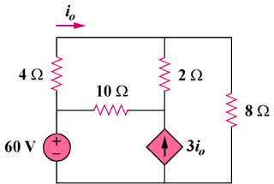

35 V

Figure 3.95
For Prob. 3.50.

Solution
–
+

35 V

3i₀

i₁

i₂

i₃

2 Ω

8 Ω

4 Ω

10 Ω

i₂

i₃

For loop 1, 16i₁ – 10i₂ – 2i₃ = 0 which leads to 8i₁ – 5i₂ – i₃ = 0 (1)

For the supermesh, –35 + 10i₂ – 10i₁ + 10i₃ – 2i₁ = 0

or –6i₁ + 5i₂ + 5i₃ = 17.5 (2)

Also, 3i₀ = i₃ – i₂ and i₀ = i₁ which leads to 3i₁ = i₃ – i₂ (3)

Solving (1), (2), and (3), we obtain i₁ = 1.0098 and

i₀ = i₁ = 1.0098 A

